Problem Statement: Inter-Process Communication (IPC) using Pipes, Shared Memory, and Message Queues

Design and implement efficient and reliable inter-process communication (IPC) mechanisms using pipes, shared memory, and message queues in C to facilitate data exchange and synchronization between multiple processes within a single system.

Specific Requirements:

Pipe: Create and manage unidirectional and bidirectional pipes for simple data transfer between related processes.

Shared Memory: Allocate and manage shared memory segments for efficient data sharing between multiple processes.

Message Queues: Create and utilize message queues for asynchronous communication and data exchange with message prioritization.

Synchronization: Implement appropriate synchronization mechanisms (e.g., semaphores, mutexes) to coordinate access to shared resources and prevent race conditions.

Error Handling: Incorporate robust error handling to manage potential IPC failures and resource leaks.

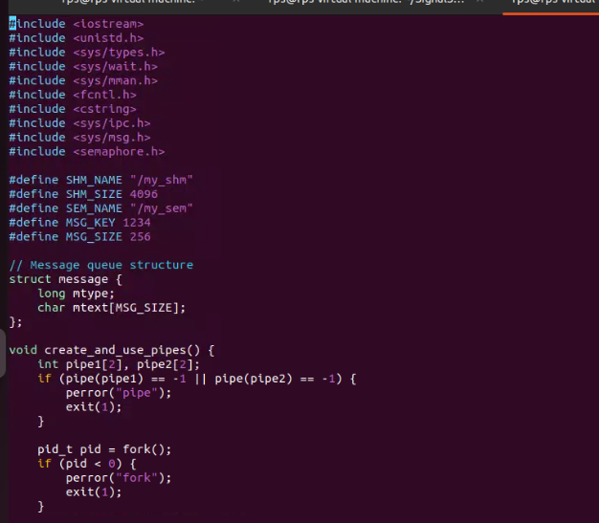

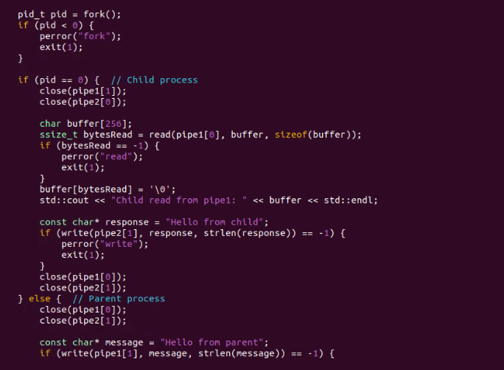

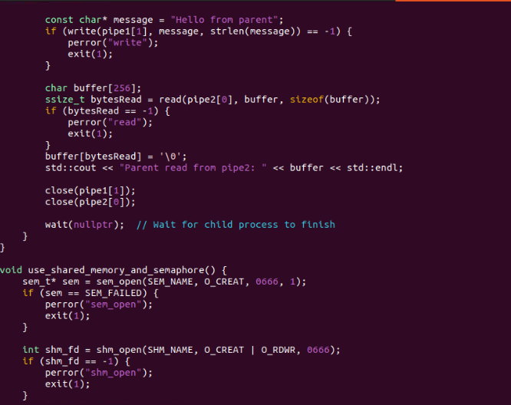

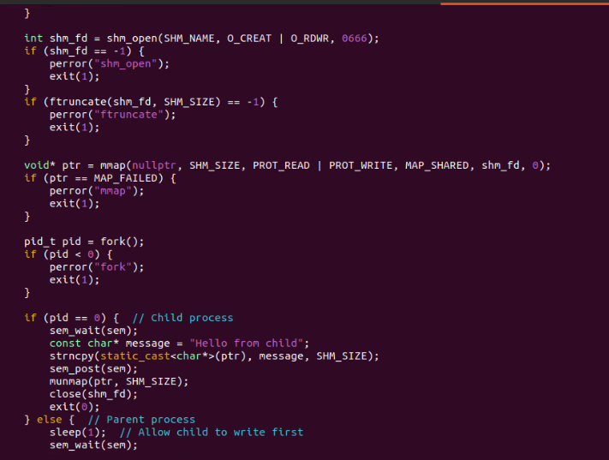

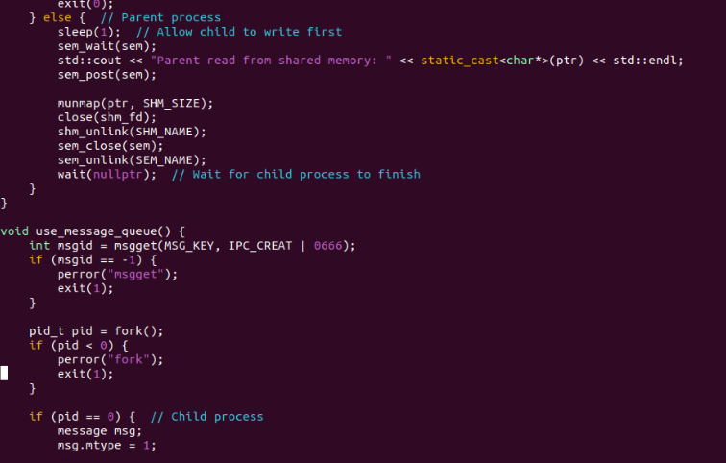

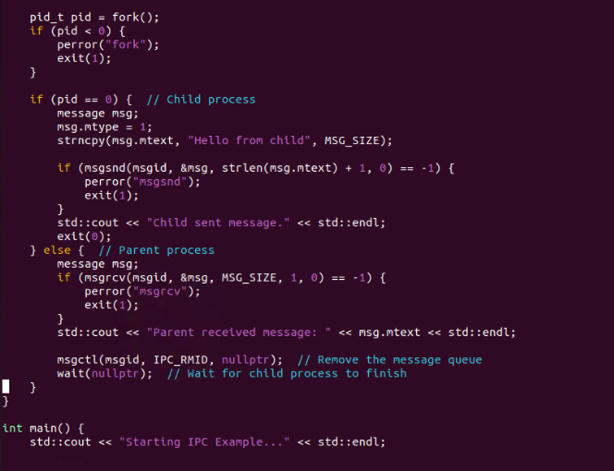

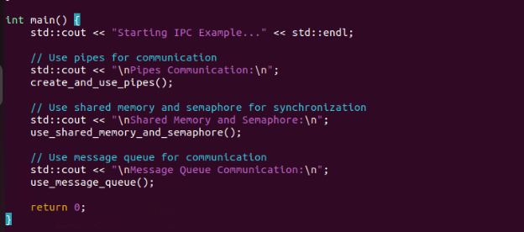OUTPUT:

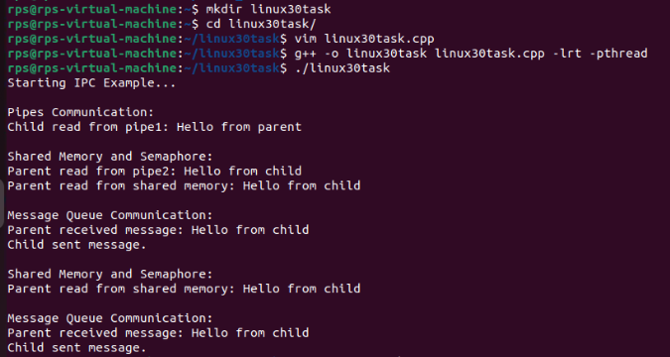

2. 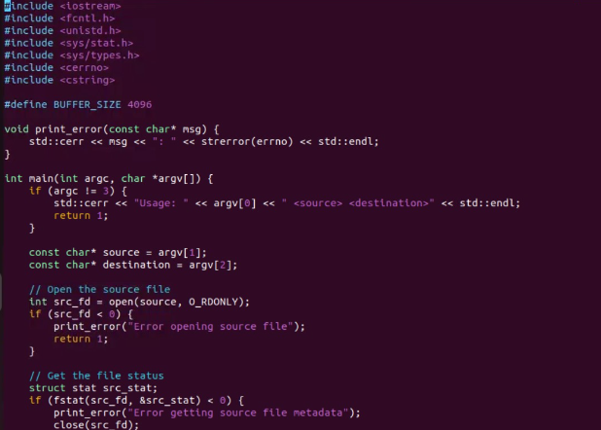

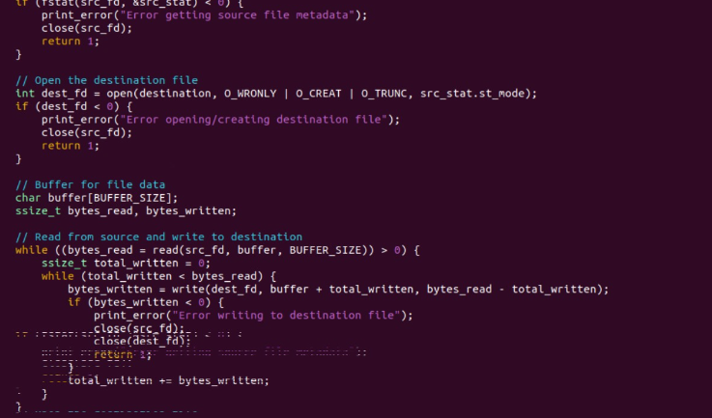

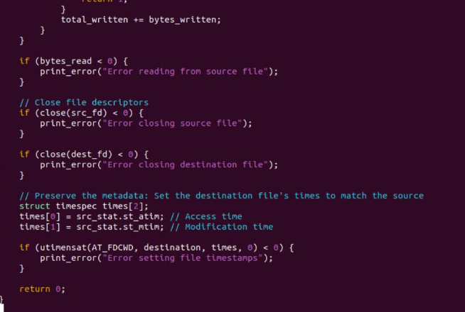

EXAM TASKS:

1.

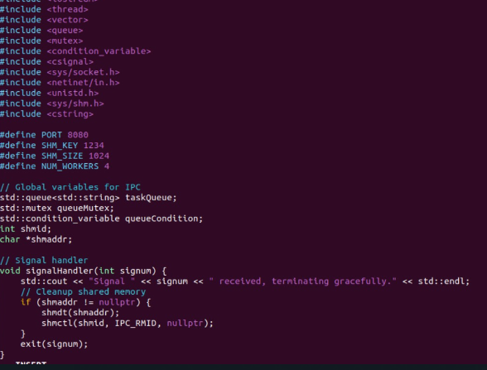

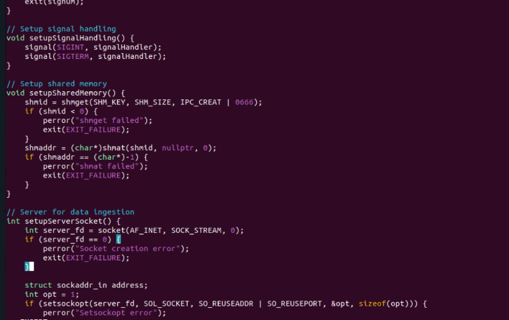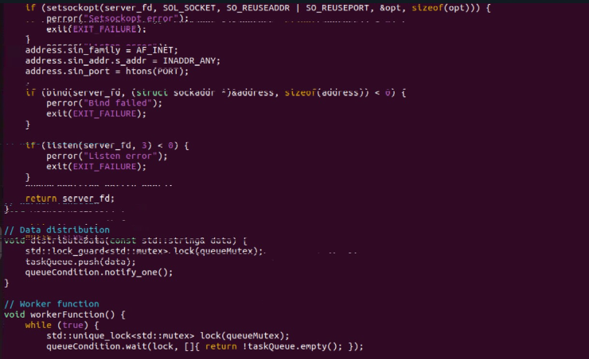

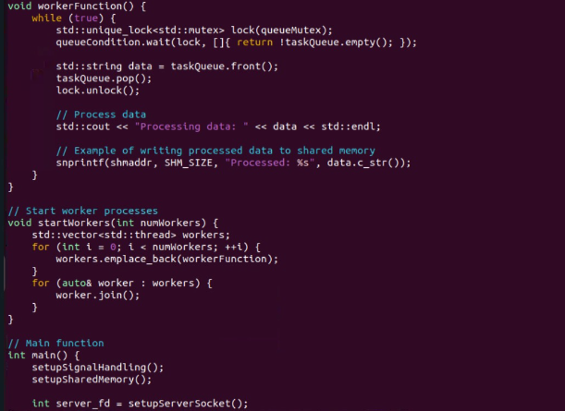

Output:

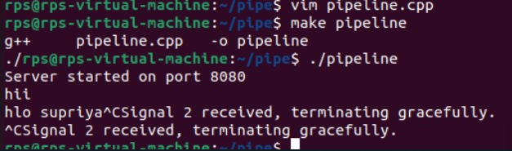

2.

Coding Questions in C++

Signal Handling:

Write a C++ program that sets up a signal handler for SIGINT. The program should perform some tasks and print a message when SIGINT is caught, then terminate gracefully.

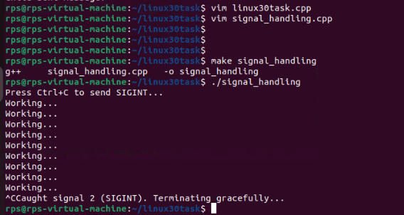

How would you modify your program to handle multiple different signals, each with a unique handling function?

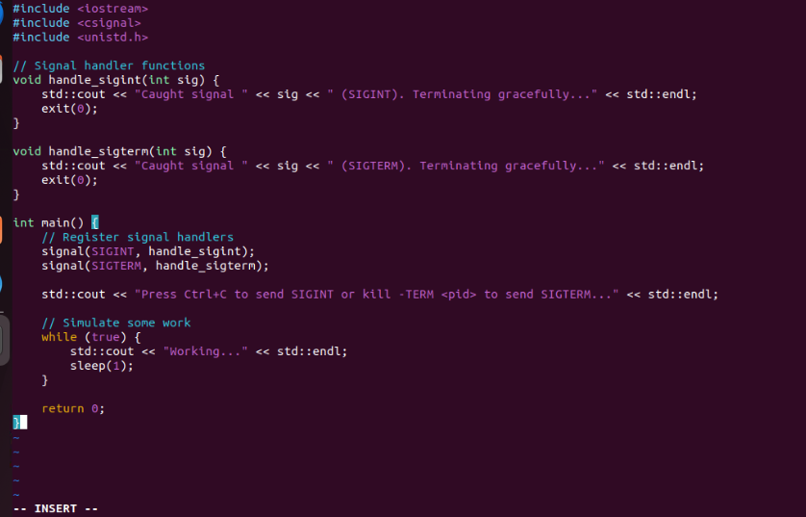

Output:

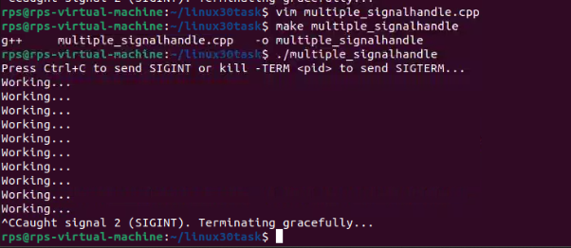

3.Sockets for Network Communication:

Implement a simple echo server in C++ that listens on a specific port, accepts client connections, and echoes back any messages received from clients.

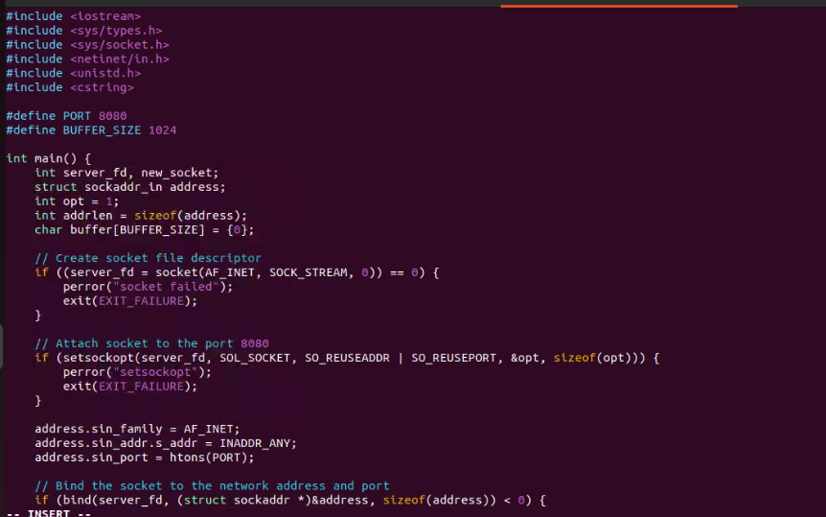

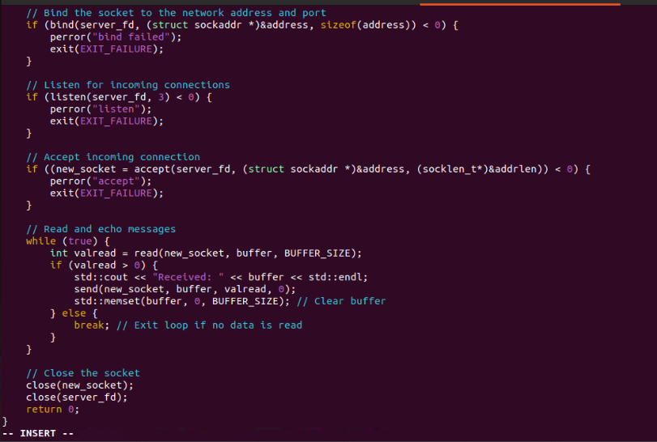

Output:



Write a client program that connects to the echo server, sends a message, and prints the echoed response.

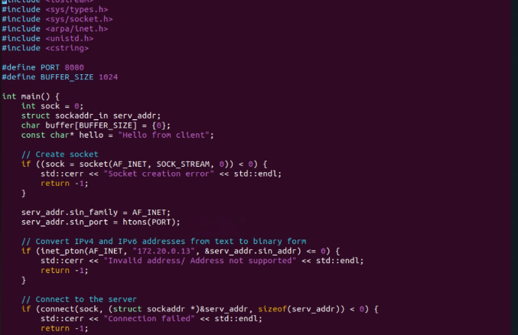

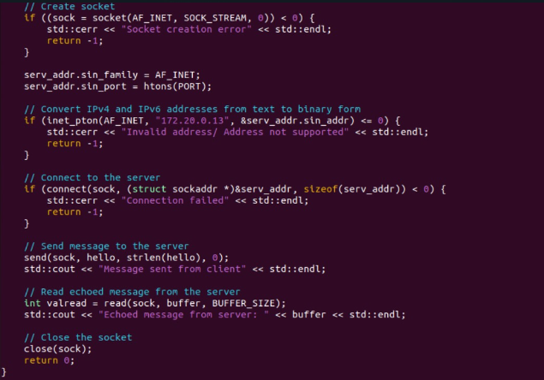

Output:

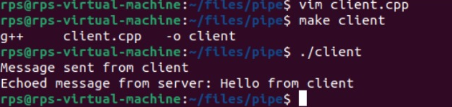

4. Inter-Process Communication (IPC):

Write a C++ program that creates a parent process and a child process. Use a pipe for IPC to send a message from the parent to the child, and have the child process print the message.

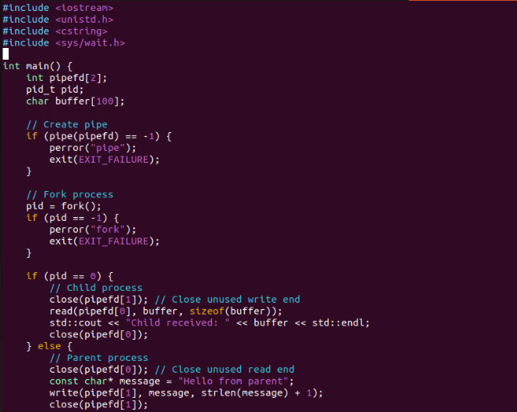

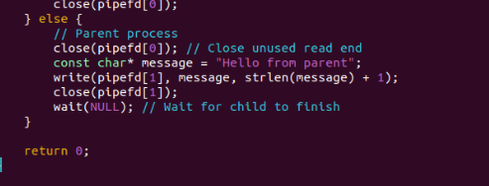

Output:



How would you modify the program to use a message queue instead of a pipe for communication between the parent and child processes?

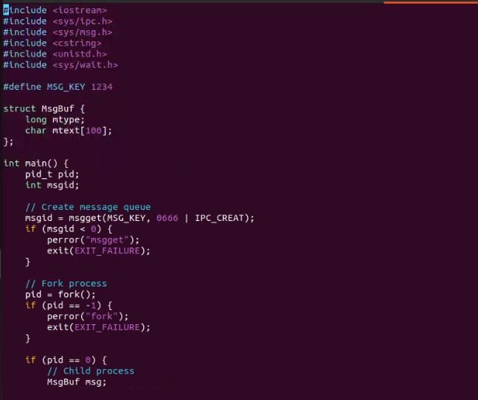

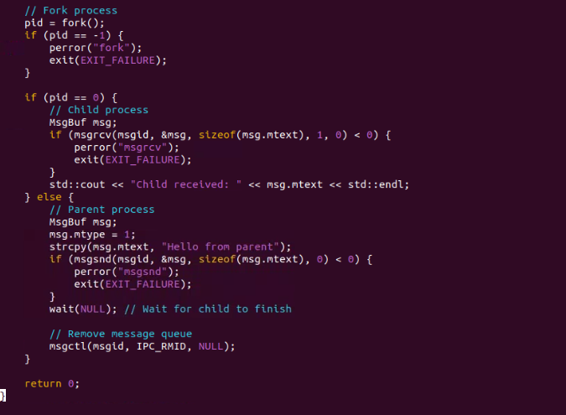

Output:

